30.63: a) In the R-L circuit the voltage across the resistor starts at zero and increases to the battery voltage. The voltage across the solenoid (inductor) starts at the battery voltage and decreases to zero. In the graph, the voltage drops, so the oscilloscope is across the solenoid.
b) At 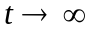the current in the circuit approaches its final, constant value. The voltage doesn’t go to zero because the solenoid has some resistance 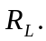The final voltage across the solenoid is 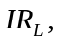where I is the final current in the circuit.
c) The emf of the battery is the initial voltage across the inductor, 50 V. Just after the switch is closed, the current is zero and there is no voltage drop across any of the resistance in the circuit.
d) As 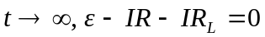
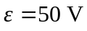 and from the graph 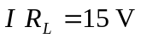 (the final voltage across the inductor), so
e)
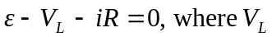 includes the voltage across the resistance of the solenoid.
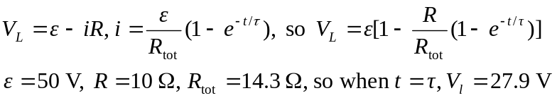
From the graph, 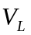 has this value when t = 3.0 ms (read approximately from the graph), so

